QCC Standard Operating Procedure
Blood Processing – Plasma- Buffy Coat and Storage
SOP Number: | 08.02.003 | Version: | e1.0
Supersedes: | NA | Category: | Materials Handling and Documentation - Blood

Approved By: | QCC Working Group | Date of approval  DD-MM-YYYY
 | Per: Insert Signature

Fields in green should be modified according to your biobank and institution

1.0 PURPOSE
Blood samples are drawn from patients that have been through the informed consent process and agreed to participate in the tumour biobank program. Blood samples are obtained by personnel qualified to draw blood from patients in the cancer centre, the hospital or in the physician’s office. Processed blood products are an important tumour biobank resource. The purpose of this document is to outline the processing of blood to harvest plasma and obtain buffy coat.

2.0 SCOPE
- This standard operating procedure (SOP) describes how blood should be processed in order to obtain and store the plasma derivative and the buffy coat.
- This SOP is intended to ensure that blood samples obtained from consented participants are processed in a safe and efficient manner while minimizing the risks of contamination and loss.
- This SOP does not provide details on safety measures essential for biological material handling. Please refer to institution biosafety guidelines (reference - to add in the table point 3.0). Personnel should have received an institutional training for biosafety and waste management. Access to the SIMDUT database (state location in your institution) and an information document on biosafety measures (indicate location) should be available

REFERENCE TO OTHER SOPS OR POLICIES

Biobank or Institutional SOP
Biohazardous Material Waste Management | TDB
Biosafety procedure | TDB
CTRNet SOP and Policies
http://www.ctrnet.ca/
Ethics | POL.002
Privacy and Security | POL.004
Records and Documentation | POL.005
Material and Information Handling | POL.007
Labelling and Tracking Materials - Biobank ID | SOP 08.01.001
Coding of Biological Specimens | SOP 08.01.008
MCC SOPs
Blood Collection and Transportation | SOP 08.02.001

4.0 ROLES AND RESPONSIBILITIES

This SOP applies to all laboratory personnel from biobanks that are responsible for the processing of blood to obtain blood products for storage in the tumour biobank. It also applies to personnel responsible for collection of the blood from the consented participant.

Personnel | Responsibility/Role
Laboratory Technician/Technologist | Transport, process and store blood and blood products  Verify specimen identification  Record information in the Blood Collection and Processing Worksheet and in ATiM

5.0 MATERIALS, EQUIPMENT AND FORMS

The materials, equipment and forms listed are recommendations only and may be substituted by alternative/equivalent products more suitable for the site-specific task or procedure.

Materials and Equipment | Materials and Equipment (Site Specific)
Laminar flow hood
5 Sterile 2 mL cryovials (Sarstedt, # 72.694.006) or bar-coded tubes
Sterile polypropylene conical tube, 15mL or 50 mL (Falcon, #352070)
4ºC Centrifuge with variable rotor angle
4ºC Centrifuge for 2ml microtube
If needed a tube with water to balance during centrifugation
Pipettors with sterile plastic tips
Transfer pipets
Pipettors with plastic tips (1000μL cut and sterile)
Aerosol-resistant pipet tips
Storage boxes
Sterile plastic pipette 5 or 10mL
Gloves worn to protect Laboratory Technician/Technologist
Appropriate racks to hold tubes while processing
Sufficient appropriate labels for collection tubes or markers
Blood Collection and Processing Worksheets | Version # 1.1

DEFINITIONS
See the CTRNet Program Glossary: http://www.ctrnet.ca/glossary

PROCEDURES

- This procedure is intended to ensure that blood samples obtained from consented participants are processed in a safe and efficient manner while eliminating the risks of contamination and loss.
- This SOP does not provide details on safety measures essential for biological material handling. Please refer to institution biosafety guidelines (reference - to add in the table point 3.0). Personnel should have received an institutional training for biosafety and waste management. Access to the SIMDUT database (state location in your institution) and an information document on biosafety measures (indicate location) should be available.

Timing for Blood Collection and Processing

Refer to SOP 08.02.001 for Blood Collection and Transportation for the steps preceding this SOP.

Verify that tubes were inverted 6-8 times after collection.

Tubes are kept at room temperature. Do not allow the samples to freeze or be exposed to an ambient temperature of greater than 25°C for more than 5 minutes.

The time requirement for sample processing depends on the intended use; therefore, time of processing should be recorded. Ideally this should occur within 4 hours from collection.

Note: Cell degradation will occur if tubes are stored for more than 4 hours

The person processing the blood should be advised in advance if different from the person transporting the specimens after collection.

Pre-cool the centrifuge.

Verification of Identification Information on Tubes

Verify the accuracy of patient information (in keeping with privacy and ethical policies) and ensure that it corresponds with the information on the labels on blood collection tubes.

Confirm that patient identifiers are appropriate on the Blood Collection and Processing Worksheet and that time of collection was recorded.

Indicate the lot and expiry date of the EDT-1 (lavender cap) collection tube, if and when it was stored on ice, the volume of blood present in tube and if there was hemolysis in the Blood Collection and Processing Worksheet.

Separation of Plasma from Blood Samples
    - Centrifuge the blood collection tubes containing the EDTA (EDT-1, lavender cap) by centrifuging at 1500 g (2000g can also be used) for 15 minutes at 4ºC.
Note: Be sure that the tubes are not loaded in the outer positions of the carriers, as this may cause the rubber tops of the tubes to contact the rotor and come off. If a lid is available, it would need to be on. Use balance if needed.
    - Record the centrifugation start time into the Blood Collection and Processing Worksheet.
    - During centrifugation, label 2 sterile conical tubes (15 or 50mL) with Biobank ID. In addition, label 5 sterile cryovials (Sarstedt, # 72.694.006) with Biobank ID, sample name (plasma: PLA-E1, PLA-E2, … , buffy coat: BFC-1, BFC-2), time point, and date of collection.
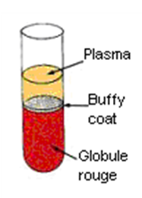
    - Carefully remove the centrifuged collection tubes and place them in an appropriate rack holder.
    - You will notice 3 different visible layers (see image on the right)
- The upper layer is generally clear and pale yellow in color, representing the plasma fraction.
- The second layer is a thin grayish-white interface band representing the leukocyte fraction (buffy coat).
- The third or bottom layer is dark red and consists of the erythrocytes or red blood cells.

Harvesting and Storage of Plasma

Bring tubes into a laminar flow hood and carefully open the tops of the tubes.
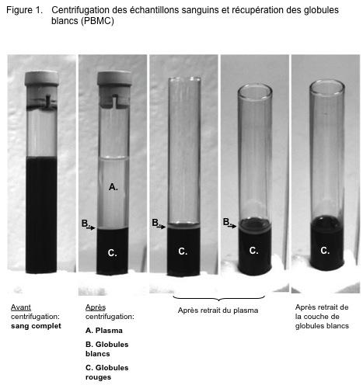
    - Using a 10 mL pipette (or a transfer pipet), aspirate the plasma layer down to approximately 5 mm from the leukocyte fraction.
Take care not to disturb the leukocyte fraction.
    - Pour the plasma in the pre-labeled conical tubes. Do not mix the material from a tube containing hemolysis with material from tubes that do not show such phenomenon.
    - Centrifuge the conical tubes containing the plasma fraction at 3000 g for 10 minutes at 4ºC (recommended, RT can also be performed). Use a balance tube if needed.
Note: An additional centrifugation can be performed if desired.
- Transfer the supernatant (serum) using a disposable transfer pipet or a 1mL Pipettor and filtered tips, into pre-labeled 1.5mL microtube(s).
- Centrifuge the microtubes at 16200g for 15 minutes at 4ºC (recommended, RT can also be performed).
    - During this centrifugation step, you may proceed with the collection and storage of the buffy coat (step 7.5).
    - After the second centrifugation, bring the collection tube into a laminar flow hood and carefully open them.
    - Using a plastic pipette or pipettor and sterile tips, Aliquot 1 mL to 1.5 mL of plasma into the 3 the pre-labelled cryovials (Sarstedt, # 72.694.006).
    - Place the cryovials in appropriate storage units. For long-term storage, -80°C or colder is recommended.
    - Record the freezing time, volume, hemolysis (ex; clear, turbid, hemolyzed or turbid and hemolyzed, storage position and location in the Blood Collection and Processing Worksheet.
    - Record information in ATiM.

Collection of Buffy Coat
    - Once the plasma is removed, use a 1000μL pipettor and sterile tips (the tip could be cut at around 0.5cm from the tip to facilitate the suction) or a disposable transfer pipet to aspirate (with a swirling motion) the buffy coat containing white blood cells and aliquot 200μL in one pre-labeled cryovial (BCF-1) and the remaining volume in a second pre-labeled cryovial (BFC-2). We usually retrieve around 500μL of buffy coat.
    - Place the cryovials in appropriate storage units. For long-term storage, -80° C or colder is recommended.
    - Record the freezing time, volume, hemolysis, storage position and location in the Blood Collection and Processing Worksheet. Record any deviations from SOP (change in time, change in centrifuge speed, change in temperature) and any unusual observations (e.g., hemolysis)
    - Record all information into ATiM

APPLICABLE REFERENCES, REGULATIONS AND PROCEDURES

Declaration of Helsinki. http://www.wma.net/en/30publications/10policies/b3/index.html

Tri-Council Policy Statement 2; Ethical Conduct for Research Involving Humans; Medical Research Council of Canada; Natural Sciences and Engineering Council of Canada; Social Sciences and Humanities Research Council of Canada, December 2018. https://ethics.gc.ca/eng/policy-politique_tcps2-eptc2_2018.html

Human Tissue and Biological Samples for use in Research. Operational and Ethical Guidelines. Medical Research Council Ethics http://www.mrc.ac.uk/Utilities/Documentrecord/index.htm?d=MRC002420

Best Practices for Repositories I. Collection, Storage and Retrieval of Human Biological Materials for Research. International Society for Biological and Environmental Repositories (ISBER). http://www.isber.org/Search/search.asp?zoom_query=best+practices+for+repositories

US National Biospecimen Network Blueprint http://biospecimens.cancer.gov/resources/publications/reports/nbn.asp

Nation Bioethics Advisory Commission: Research involving human biological materials: Ethical issues and policy guidance, Vol. I: Report and recommendations of the National Bioethics Advisory Committee. August 1999.

http://bioethics.georgetown.edu/nbac/hbm.pdf

Blood Collection: Routine Venipuncture and Specimen Handling. http://library.med.utah.edu/WebPath/TUTORIAL/PHLEB/PHLEB.html

APPENDICES

Blood Collection and Processing Worksheet

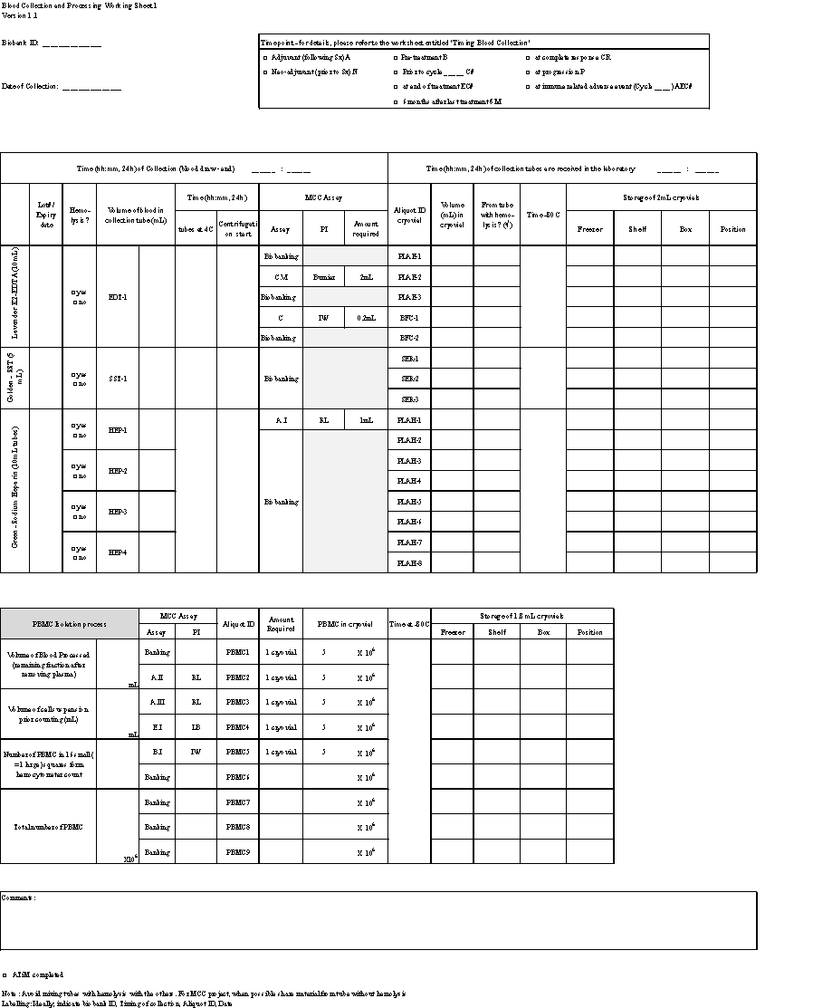

10.0 REVISION HISTORY

SOP  Number | Date  revised | Author | Summary of Revisions

